Content | Instructor Activity | Student Activity | Materials & Notes
Introduction  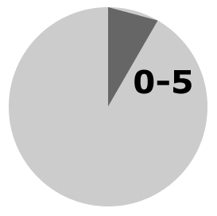 | Begin Class  - Welcome the class  - Do introductions  - Complete “flight attendant duties”: Bathrooms, emergency exits, coffee mess, pencil sharpeners, trash bins, wireless internet password, etc | - Participate in introductions  - Pay for coffee mess (if not done already) | PPT Slide 1: Intro  Slide 2:
Overview: Module 5 | Outline module content  - Lesson 1  - Break  - Lesson 2  - Break  - Lesson 3  - Final Activity | Questions as appropriate | PPT Slide 3-4: Advanced Organizer overview  Gain attention, link to past, reflect, motivate
Lesson 1: Connect  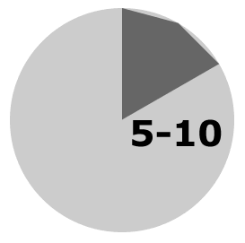 | Using Your Body  - Non-verbal communication  Deliver Lesson overview from Slide 3. Refer to notes section of the PPT for key points and teaching aids. | - Follow along in student guide, pages | PPT Slide 3
Lesson 1: Connect | Posture  Deliver Instruction for Slides 4 – 7 about Posture. Refer to notes section of the PPT for key points and teaching aids. | - Follow along in student guide, pages | PPT Slides 4-7
Content | Instructor Activity | Student Activity | Materials & Notes
Lesson 1: Apply  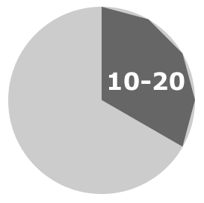 | - Introduce Examples  - Demo Practice Elements  - Assign Elements to students  - Assign Case Studies | - Get a partner  - Show them how to make a peanut butter sandwich, without talking…  - Use a good SOLER posture  - Evaluate your partner  - Switch! | PPT Slide 8  Evaluation Cards
Lesson 1: Connect  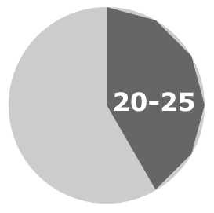 | Eye Contact  - Non-verbal communication  Deliver Instruction for Slides 9 – 13 about Eye Contact. Refer to notes section of the PPT for key points and teaching aids. | - Follow along in student guide, pages 6-7 | PPT Slides 9-13
Lesson 1: Apply  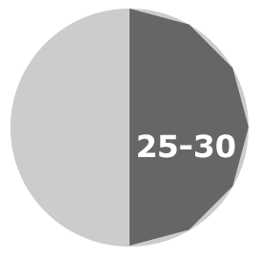 | - Introduce Examples  - Demo Practice Elements  - Assign Elements to students  - Assign Case Studies | - Get a (different) partner  - Tell them about your last vacation  - Maintain good eye contact, for both presenting and receiving  - Evaluate your partner  - Switch! | PPT Slide 14  Evaluation Cards
Lesson 1: Connect  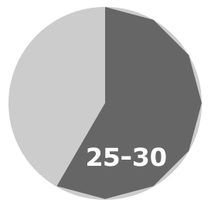 | Gestures  - Non-verbal communication  Deliver Instruction for Slides 15–20 about Gestures. Refer to notes section of the PPT for key points and teaching aids. | - Follow along in student guide, page 8. | PPT Slides 15-20
Content | Instructor Activity | Student Activity | Materials & Notes
Lesson 1: Apply  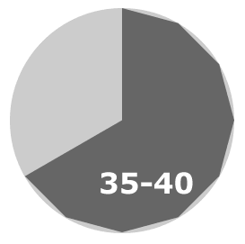 | - Introduce Examples  - Demo Practice Elements  - Assign Elements to students  - Assign Case Studies | - Get a (different) partner  - Show them how to make a peanutbutter sandwich, without talking  - Evaluate your partner  - Switch! | PPT Slide 21  Evaluation Cards
Lesson 1: Reflect  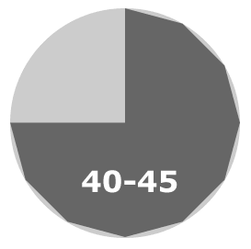 | Posture: SOLER  Eye contact techniques  Gestures | PPT page 9 | PPT Slide 22
BREAK  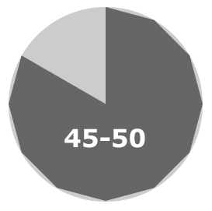 | - Time check  - Reconvene in 5 minutes  - Available for questions | Break!   | PPT Slide 23  Coffee, tea, donuts, etc.
Lesson 2: Connect  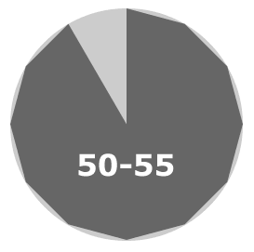 | Using your voice  Lesson overview  - VATS voice  - Vocabulary  - Avoiding the “UM” | Follow along in student guide, page 10. | PPT Slides 24-25
Content | Instructor Activity | Student Activity | Materials & Notes
Lesson 2: Connect | Volume  Lesson overview  - VATS voice  - Vocabulary  - Avoiding the “UM” | Follow along in student guide, page 11. | PPT Slide 26
Lesson 2: Connect   | Articulation  Lesson overview  - VATS voice  - Vocabulary  - Avoiding the “UM” | Follow along in student guide, page 11. | PPT Slide 27
Lesson 2: Connect  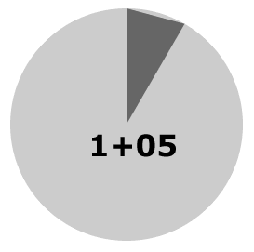 | Tone  Lesson overview  - VATS voice  - Vocabulary  - Avoiding the “UM” | Follow along in student guide, page 12. | PPT Slide 28
Lesson 2: Connect  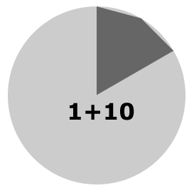 | Speed  Lesson overview  - VATS voice  - Vocabulary  - Avoiding the “UM” | Follow along in student guide, page 12. | PPT Slide 29
Content | Instructor Activity | Student Activity | Materials & Notes
Lesson 2: Connect | Vocabulary  - Spell out all acronyms  - Speak in basic terms (unless material demands otherwise).  - Define new words, and repeat them in context  - Offer a glossary if you have a lot of technical terms | Follow along in student guide, page 13. | PPT Slide 30
Lesson 2: Connect  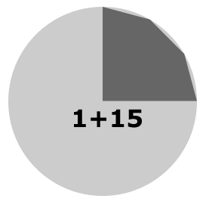 | Avoiding “UM”  - Know your material!  - Turn transparent behavor opaque  - Fill the space with something else | Follow along in student guide, page 14. | PPT Slide 31-32
Lesson 2: Apply  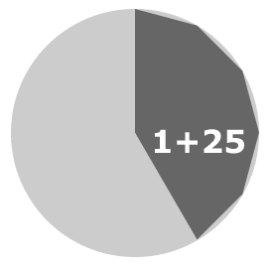 | - Introduce Examples  - Demo Practice Elements  - Assign Elements to students  - Assign Case Studies | - Get form a group of 3-4  - Teach everyone a technical skill (tie a knot, wrap a package, make orange juice, or something else)  - Evaluate the speaker  - Switch! | PPT Slide 33  Evaluation Cards
Lesson 2: Reflect  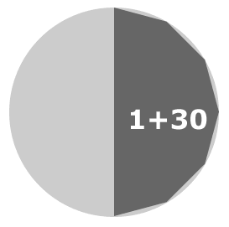 | - VATS Voice: When to use?  - Vocabulary tactics  - Filler sounds | Follow along in student guide, page 15. | PPT Slide 34
Content | Instructor Activity | Student Activity | Materials & Notes
BREAK  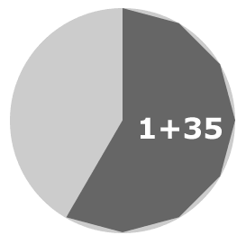 | - Time check  - Reconvene in 5 minutes  - Available for questions | Break! | PPT Slide 35  Coffee, tea, donuts, etc.
Lesson 3: Connect  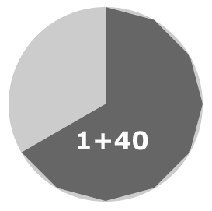 | Active Listening  - P.E.G. (review)  - Paraphrasing  - Summarizing  - Empathy | Follow along in student guide, page 14. | PPT Slide 36
Lesson 3: Connect | P.E.G. Review  - SOLER posture while listening  - Eyes - use eyebrow raises  - Gestures - don’t distract the talker | Follow along in student guide, page 14. | PPT Slide 37
Lesson 3: Connect | Paraphrasing  - Paraphrasing is repeating in your own words.  - Communicates how well you’re listening  - Leading comments | Follow along in student guide, page 14. | PPT Slide 38
Content | Instructor Activity | Student Activity | Materials & Notes
Lesson 3: Connect  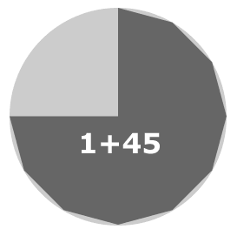 | Summarizing  - Make what they said shorter  - Different from paraphrasing: building shortened comments  - Leading statements | Follow along in student guide, page 17. | PPT Slide 39
Lesson 3: Connect | Empathy  - “Feeling” for the listener  - Reflect their emotion  - Leading statements | Follow along in student guide, page 17. | PPT Slide 40
Lesson 3: Apply  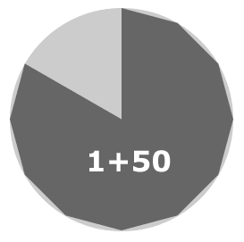 | - Introduce Examples  - Demo Practice Elements  - Assign Elements to students  - Assign Case Studies | - Get form a group of 3-4  - Teach everyone a technical skill (tie a knot, wrap a package, make orange juice, or something else)  - Evaluate the speaker  - Switch! | PPT Slide 41 - 42  Evaluation Cards
Lesson 3: Reflect  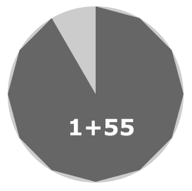 | - Use good posture, eye contact, and encouraging gestures  - Paraphrase short comments  - Summarize long comments  - Empathize reflecting emotion | Follow along in student guide, page 18. | PPT Slide 42
Content | Instructor Activity | Student Activity | Materials & Notes
Module 1: Reflect  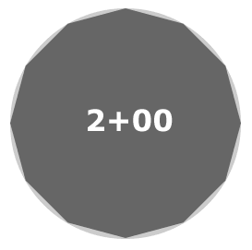 | Debrief Module  Administer surveys  Collect roster | Offer comments  Complete surveys | PPT Slides 43-44

Notes:

